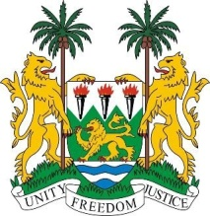
SIERRA LEONE

26th session of the UPR

SOUTH SUDAN

STATEMENT BY SIERRA LEONE

7 November 2016

Mr President,

Sierra Leone welcomes the delegation of South Sudan to this UPR session and thanks them for their presentation.

It is notable that since 2008, the government has enacted 133 legislative norms and domesticated 11 international and regional conventions.

Sierra Leone also notes the efforts to establish a Transitional Government of National Unity and calls on all parties to actively engage in a peaceful resolution to the conflict. Meanwhile, international humanitarian and human rights laws must be respected.

An end to the conflict would enable the Government of Sudan to address the pressing needs to ensure the fulfilment of all human rights of its peoples.

In its National Report, South Sudan has pleaded for assistance in capacity building and for technical assistance to meet its human rights commitments. My delegation calls on the international community to heed this call.

Recommendations:

- Ratify ICESCR and ICCPR and other core international human rights treaties and conventions it is not yet party to.
- Investigate and prosecute all incidents of sexual violence perpetuated by both parties to the conflict.
- Strengthen transitional justice by establishing the hybrid court and a truth and reconciliation commission.

To conclude, Sierra Leone wishes South Sudan a successful completion of this second UPR cycle.

Thank you, Mr President.

